Statement of Insurance for Entertainments Licence purposes | 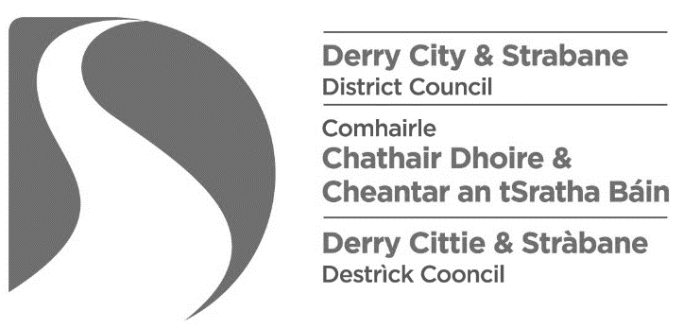

This statement must either be accompanied by a covering letter, on the insurer’s headed notepaper, or otherwise verified, e.g. by means of an official stamp or seal

I / we*, the undersigned, confirm that the details of the insurance policy, that is in force in respect of the premises named herein, are as follows:
Premises:

Policy number:

Date renewal is due:

Limits of indemnity: | A. Public liability cover: | £
 | B. Employer’s liability cover: | £
Please provide details of any restrictive endorsements which may affect the type(s) of entertainment that may be provided on the premises:

Signed: |  | Date:
on behalf of |  |  | Company stamp
 | [insert name of company]

