
DERRY STRABANE LABOUR MARKET PARTNERSHIP ACTION PLAN 2025-2026

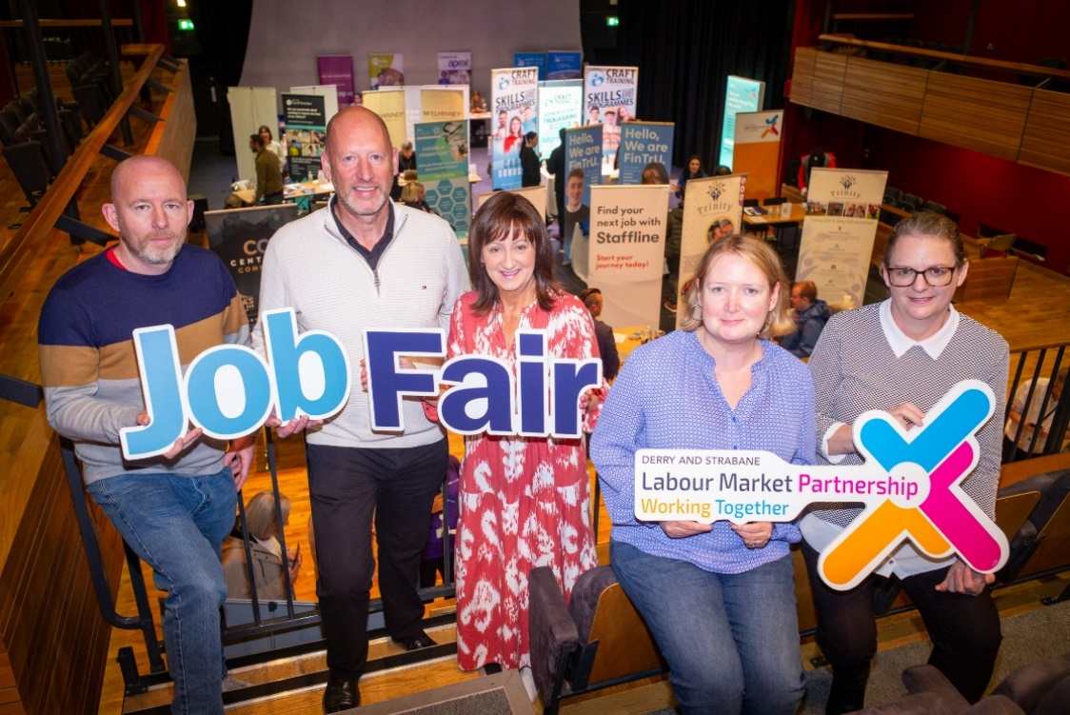
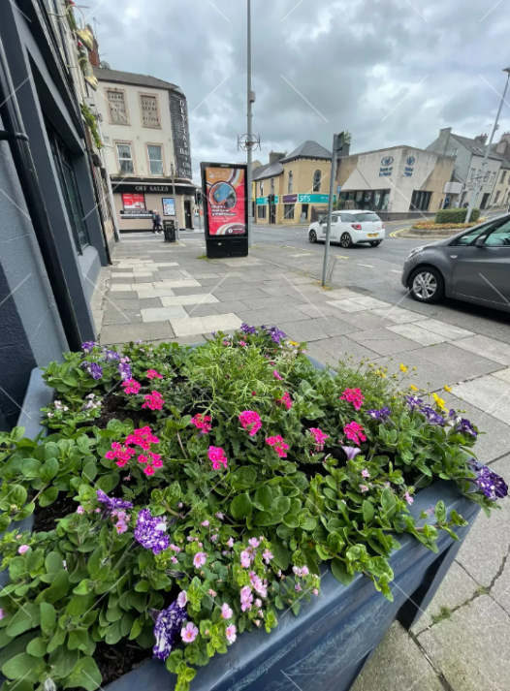
 |  |  | Page
INDEX |  |  | 1
 | Introduction
 | 1.1 | Introduction | 2-3
1. | Review of Strategic Assessment
 | 1.1 | Introduction | 4
 | 1.2 | Northern Ireland and Local Context | 4-5
 | 1.3 | Conclusion | 6
2. | Turning the Curve
 | 2.1 | Introduction | 7
 | 2.2 | Turning the Curve | 8-14
3. | LMP Action Plans 2025/26
 | 3.1 | Introduction | 15
 | 3.2 | Action Plan Baseline | 15-17
 | 3.3 | Action Plan 2025-26 | 18-36

Introduction

The 3-year Strategic Assessment 2024/27 was reviewed and remains in place. The actions proposed in the LMP Plan are consistent with the aims and objectives of the Council’s Corporate Plan 2023/24, Inclusive Strategic Growth Plan and City Deal. These actions reflect the findings from a statistical and consultative process, namely that the labour market has persistent challenges including high levels of economic inactivity, high claimant count rates and significant pockets of deprivation.

These labour market challenges constrain faster economic growth, impacting on overall economic development. Reflecting on the analysis, the proposed Action Plan will adhere to DfC LMP’s Strategic Priorities:

Strategic Priority 1 – To form and successfully deliver the functions of the local Labour Market Partnership for the area by:
- Reviewing available statistical information and engaging key stakeholders to identify employability or the labour market issues locally and addressing those issues;
- Preparing the LMP’s plans and organising the work of the partnership to meet priority needs;
- Putting in place implementation structures and delivery mechanisms that will contribute towards improved employability outcomes and/or labour market conditions. This may be achieved directly through the collaborative working of partnership members, through the work of its delivery groups or through working in partnership with, or supporting the work of others; and
- Increasing LMP awareness with the public and key stakeholders by planning communications activity to more proactively inform and promote the work of LMPs.

Strategic Priority 2 – To improve employability outcomes and/or labour market conditions locally by:
- Working in partnership with stakeholders including local statutory bodies/agencies, businesses, the voluntary sector and the community to address locally identified issues;
- Ensuring that local statutory bodies and agencies address employability and labour market conditions locally in their area, and where possible in collaboration with other key stakeholders;
- Providing comprehensive input into decision making processes about tackling actual and perceived barriers or negative impacts on employability or labour market conditions locally and giving feedback on the effectiveness of interventions on meeting outcomes;
- Identifying and implementing ways to educate communities and the local work force about employment opportunities or local labour market conditions; and
- Contributing to delivery of LMP Partnership Plans and initiatives that improve employability outcomes and/or labour market conditions locally.

Strategic Priority 3 – To promote and support delivery of existing employability or skills provision available either regionally or locally through:
- Promotion of relevant existing projects/initiatives, including building confidence and awareness through locality based engagement;
- Inclusion of initiatives/projects within local LMP Partnership Plans aimed at meeting the relevant objectives of the PfG and/or local Community Plan;
- Contribute to development of and/or make participant referrals to regional or other relevant local initiatives/projects aimed at improving employability and labour market conditions;
- Escalation of relevant issues and/or identifying priorities to be considered by the Regional LMP; and
- Contributing to public facing events and supporting effective engagement with an emphasis on improving employability outcomes and/or labour market conditions.

The following themes are local priorities within the Plan.

- Disability: People who report a physical or mental health condition(s) or illnesses lasting or expected to last 12 months or more where this reduces their ability to carry out day-to-day activities.
- Skilled Labour Supply: DfE’s 2021 Skills Barometer utilises the National Qualification Framework (NQF) Skills Classification. residents of working age population with no qualifications.
- Economic inactivity: people not in employment who have not been seeking employment within the last four weeks and/ or are unable to start work in the next two weeks.
- Unemployment: people who are without a job, currently available to work, and have been actively looking for work within the previous four weeks.

Review of Strategic Assessment

  - Introduction
A comprehensive review of relevant strategic documents has been undertaken at an NI and Council level. The broad objective of these policy documents is to promote and deliver a better economic outcome for NI and its residents.

In December 2024 a review of the 2024/27 Strategic Assessment was carried out by Derry and Strabane LMP to review employability outcomes and local labour market conditions in the Derry City and Strabane District Council Area.

This exercise was undertaken to ensure that the priorities identified continue to reflect priority employability and labour market issues in the area and was informed by analysis of information provided by statutory partners, as well as the results of ongoing engagement and consultation across the council area.

  - Northern Ireland and Local Context

Cognisance was also taken of, for example, the Our Plan: Doing What Matters Most Draft Programme for Government (PfG) 2024–2027, Derry City and Strabane District Council Inclusive Strategic Growth Plan, Corporate Growth Plan 2023/24 + City Deal.

NI Executive, Our Plan: Doing What Matters Most Draft Programme for Government (PfG) 2024 – 2027:
“Our Plan is focused on doing what matters most for you today: transforming our public services, supporting businesses, and improving the lives of employees, families, and communities. We want to make this an even better place to live, work and visit and Our Plan will help make this a reality.”

DSLMP’s Action Plan will align closely with the Draft PFG 2024-27
Our levels of economic inactivity are too high, with a disproportionate number of people not in employment due to ill health or disability when compared to similar jurisdictions

Our workers are paid less than their peers elsewhere and we need to make sure that we are building the skills needed to attract investment which can grow our economy and benefit workers everywhere.

Ensure that everyone, no matter where they live, can have well-paid and fulfilling jobs -
this includes sectoral partnerships to improve pathways into good jobs, a focus on technical and vocational qualifications, and provide opportunities for those returning to the labour market.

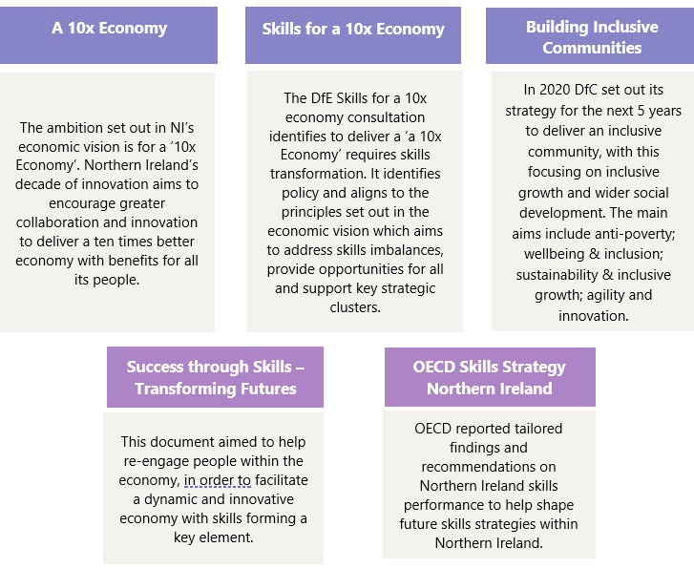
Derry City and Strabane District Council Corporate Plan 2023/24
Derry City & Strabane District’s Inclusive Strategic Growth Plan

The plan sets out the city and district’s priorities to achieve its mission of delivering “Improved social, economic and environmental outcomes for everyone”.
This document sets out the vision for Derry City and Strabane District Council area for the period 2017 – 2032 to have “a thriving, prosperous and sustainable City and District with equality of opportunity for all.”

Local Growth Partnerships
Derry City and Strabane LMP 2022/23l

Derry City and Strabane City Deal

Eight Local Growth Partnerships have been established across the eight local District Electoral Areas and Strabane town and aim to deliver on the needs and aspirations for residents and individuals at a local level.
This sets out the action plan for Derry City and Strabane’s Labour Market Partnership, which aims to help improve employability outcomes and labour market conditions locally by working through coordinated, collaborative, multi-agency partnerships.

The largest single investment package by Government into the area, City Deal is designed to create new jobs and employment opportunities and leverage additional investment to accelerate inclusive economic growth through a medium to long term investment.

  - Conclusion

The conclusion remains the same as for the 2024/25 Strategic Assessment.

As a result of the following Themes have been identified as local priority:
- Economic Inactivity
- Unemployment
- Disability
- Skilled Labour Supply

A Turning the Curve Exercise has been undertaken to consider LMP Action Plan priority themes, projects and programmes of work in relation to the desired outcomes.

Turning the Curve

  - Introduction

Since 2016, the Outcomes-Based Accountability (OBA) Approach has been the basis of a fundamental shift in how organisations across NI planned to deliver improvements in public services. With it, there was a greater focus on outcomes of societal wellbeing, rather than inputs, processes, and outputs of public services, and requires a major cultural shift in our thinking. Effective partnership working across a range of different agencies and professionals will be key to the planning and delivery of improved outcomes.

The Derry City and Strabane Inclusive Strategic Growth Plan and Community Plan 2023-24 presents an overview of the key strategic priorities for the council area. Delivery of these, as well as the LMP Action Plan are dependent on strategic and cross-cutting work, with active involvement from stakeholders in every sector, aimed at tackling the biggest challenges facing society.

According to the OBA process, progress towards outcomes is driven through Delivery Plans which analyse the available evidence about the current position and articulate the actions and interventions that the collective agencies will use to ‘turn the curve’ and achieve long-term change. The impact of actions within Delivery Plans is monitored through performance level Report Cards, which set out how much has been done; how well it has been done; and whether anyone is better off.

A turning the curve exercise was undertaken with the Partnership on 7th February 2024. Members were provided with statistics on the current trend in, for example, unemployment, economic inactivity, education, and disability employment rates. The results reconfirmed the value of the objectives and outcomes set out in the previous LMP Action Plan. The outcomes and corresponding indicators for the LMP Action Plan 2024-26 and Strategic Assessment for 2024/25 to 2026/27 The identified local priorities are detailed below. It is important to note that the LMP Plan will not be solely responsible for the labour market outcomes across Derry City and Strabane – NI wide programmes and initiatives not delivered through the LMP will also play a part.

  - Turning the Curve Assessment

INDICATOR for SP1

Theme: To form and successfully deliver the functions of the local Labour Market Partnership for the area.

Indicator: % of LMP members who feel that they are contributing to the delivery of the LMP.
(Source: LMP)

OUTCOMES
Labour Market Partnership  - Deliver a successfully functioning Local LMP. | Community Plan  - We prosper through a strong, sustainable and competitive economy.  - We are better skilled and educated. | Programme for Government  - We have a more equal society.  - We have more people working in better jobs.
POPULATION: Labour Market Partnership members.

WHAT IS THE CURRENT STATE OF PLAY?

% of LMP members who feel the Local LMP is making a positive contribution and delivering effectively

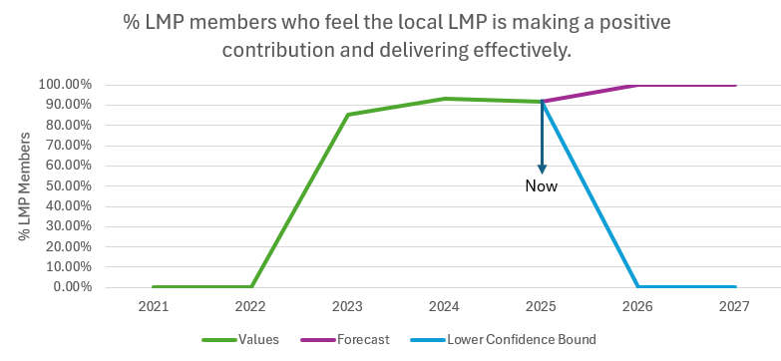

Source: Derry City and Strabane District Council LMP

COMMENTS: the LMP Partnership provides an opportunity for members to be involved in the development, delivery and monitoring of strategic assessments and action plans for the council area. As a result of this process, and the increased communication and interaction between members, it is estimated that 100% of LMP members will believe the LMP is having a positive impact by 2026.

INDICATOR for SP2 theme: Disability

People who report a physical or mental health condition(s) or illnesses lasting or expected to last 12 months or more where this reduces their ability to carry out day-to-day activities.

Indicator: % of people with a disability in employment.
(Source: LMI Portal)

OUTCOMES
Labour Market Partnership  - Promote and deliver an LMP that contributes to assisting people with a disability into employment. | Community Plan  - We prosper through a strong, sustainable and competitive economy.  - We live long, healthy and fulfilling lives. | Programme for Government  - We have a more equal society.  - We have more people working in better jobs.
POPULATION: residents of Derry City and Strabane who have a physical or mental health condition(s) or illnesses lasting or expected to last 12 months or more where this reduces their ability to carry out day-to-day activities.
WHAT IS THE CURRENT STATE OF PLAY?

Employment Rate by Disability Status, ages 16 to 64

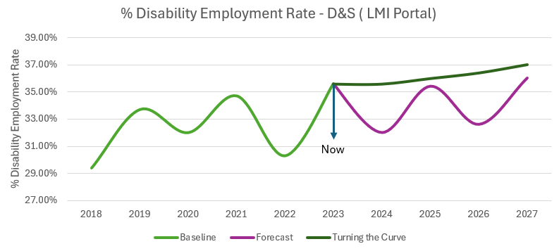

Source: LMI Portal

COMMENTS: in 2022 Derry City and Strabane had an employment rate of 30.3% for people with disabilities compared to an employment rate of 80.2% for people without disabilities. Increasing to 35.6% in 2023, the work of the Derry City and Strabane LMP will continue to aim to decrease this employment gap for people with disabilities by working towards an employment rate of 37% by 2027.

INDICATOR for SP2 theme: Economic Inactivity

Those not in employment and who have not been seeking work within the last 4 weeks and/or not able to work within the next 2 weeks.

Indicator: % Working Age Economic Inactivity Rate in Derry City and Strabane (Source: NISRA Labour Force Survey Local Area Database).
The NISRA Labour Force Survey (Local Area Database) data used includes students.

OUTCOMES
Labour Market Partnership  - Reduce Economic Inactivity | Community Plan  - We prosper through a strong, sustainable, and competitive economy.  - We are better skilled and educated. | Programme for Government  - We have a more equal society.  - We have more people working in better jobs.
POPULATION: residents of Derry City and Strabane who are not in employment and who have not been seeking work within the last 4 weeks and/or not able to work within the next 2 weeks.
WHAT IS THE CURRENT STATE OF PLAY?

% Working Age Economic Inactivity Rate in Derry City and Strabane

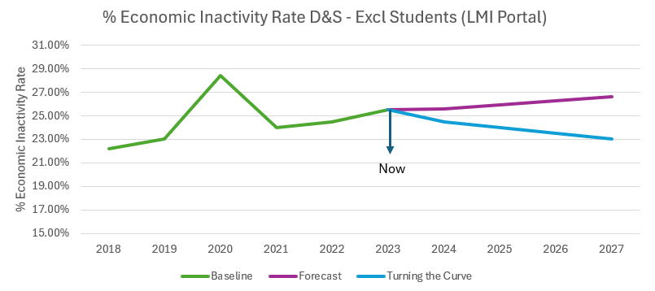

Source: LMI Portal

COMMENTS: Derry City and Strabane’s rate of economic inactivity remains above the NI average, a trend witnessed across the data series from 2018. In 2020 economic inactivity peaked at 28.4% before recovering in 2021 to 24% and slowly increasing thereafter.

It is intended that the work of the Derry City and Strabane LMP will help the level of economic inactivity to edge closer to Northern Ireland levels.

INDICATOR for SP2 theme: Unemployment

People who are without a job, currently available to work, and have been actively looking for work within the previous four weeks.

Indicator: # Claimant Count Annual Averages
(source: NINIS - LGD2014, Ward & SOA)

OUTCOME(S)
Labour Market Partnership  - Reduce the claimant count to below pre-pandemic levels and prevent those on the claimant count becoming long-term unemployed. | Community Plan  - We prosper through a strong, sustainable, and competitive economy.  - We are better skilled and educated. | Programme for Government  - We have more people working in better jobs.
POPULATION: residents of Derry City and Strabane who are in receipt of an unemployment benefit and searching for work.
WHAT IS THE CURRENT STATE OF PLAY?

Claimant Count Annual Averages: Derry City and Strabane

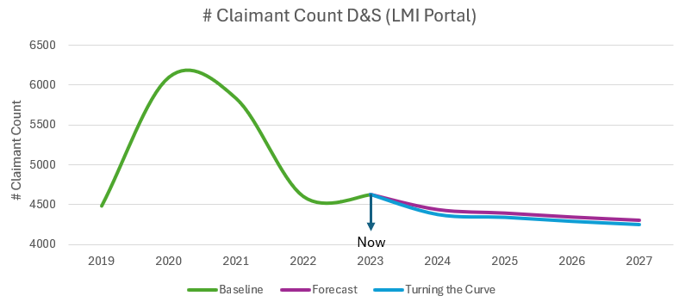

Source: LMI Portal

COMMENTS: The Covid-19 pandemic created a huge surge in the Claimant Count in 2020 and 2021, before a sharp decrease in 2022, with levels stabilising again in 2023. The Claimant Count however is still slightly above pre-pandemic levels highlighting more is needed to bring these people back to the labour market and prevent them becoming long term unemployed. 2023 DCSDC CC sits 1.8 pp above the NI average.

It is therefore intended that the work of the Derry City and Strabane LMP will aim to reduce claimant count to below pre covid levels.

INDICATOR for SP2 theme: Skilled Labour Supply

DfE’s 2021 Skills Barometer utilises the National Qualification Framework (NQF) Skills Classification.

Indicator: % Working age: no qualifications
(Source: NISRA Labour Force Survey Local Area Database)

Indicator: Gross Median Wage (£)
(Source: NINIS – LGD2014)

OUTCOME(S)
Labour Market Partnership  - Reduce the proportion of the working age population with no qualifications | Community Plan  - We prosper through a strong, sustainable and competitive economy.  - We are better skilled and educated | Programme for Government  - Everyone can reach their potential.  - Our children and young people have the best start in life.
POPULATION: residents of Derry City and Strabane who are aged 16 to 64 years old and have no or low qualifications.
WHAT IS THE CURRENT STATE OF PLAY?

% of Working Age with No Qualifications in Derry City and Strabane

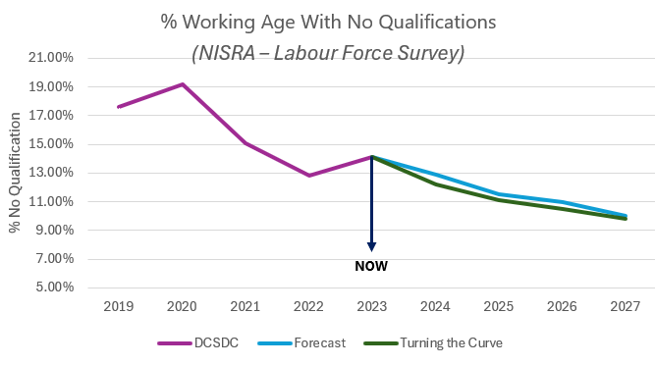
Source: NISRA – Labour Force Survey Local Area Database

Gross Median Wage (£)

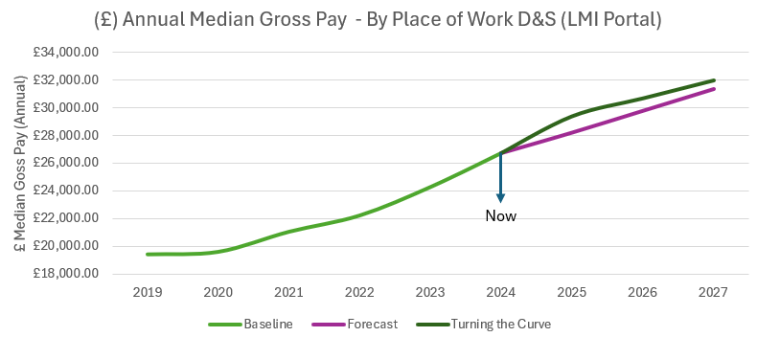

Source: LMI Portal

COMMENTS: Despite the council area having a varied resident skill base, local employers are still facing staffing and recruitment issues. With the shift in skills focus and the move to promote higher skilled jobs, concerns arise that residents without those skills will be ‘locked’ out of the employment market, especially those residents from areas of deprivation.

The council area has a lower-than-average proportion of school leavers who go on to further education and a lower-than-average rate of resident population with RQF of Level 4 and above. It is therefore important that the work of the Derry City and Strabane LMP will help continue the current trend of reducing the level of those without any qualifications and provide avenues for residents to upskill and access the future roles which require higher qualification levels.

INDICATOR for SP3

Theme: To promote and support delivery of existing employability or skills provision available either regionally or locally

Indicator: # LMP referrals to existing regional + local employability / skills provision.

POPULATION: All people seeking employment through DSLMP / DSLMP supported events.

WHAT IS THE CURRENT STATE OF PLAY?

# Referrals to existing regional and local employability and skills provision.

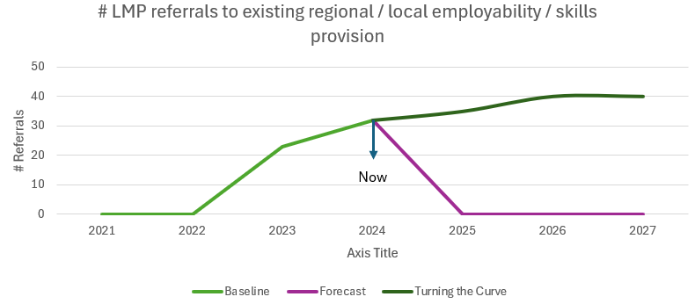

Source: Derry City and Strabane District Council LMP

COMMENTS: the LMP has a duty to assist as many people as possible who require help getting into employment. If not directly through LMP it is pertinent that referrals are made to appropriate sources.

LMP Action Plan 2025-26

  - Introduction

The Labour Market Partnership Action Plans for 2025-2026 have been developed to deliver improved employability across the Derry City and Strabane District Council area. The Partnership’s role will be to use the resources made available through the Department for Communities and other available resources to improve employability outcomes. The LMP Plan will be underpinned by a true partnership and the principles of professionalism, clarity, courtesy, inclusiveness, transparency, ambition, realism, practicality, adaptability, and accessibility between all members of the LMP which will create the conditions for success. Membership of the plenary LMP will provide focus on ‘key issues’ and set strategic direction. DSLMP provides a mechanism for users of employability and skills programmes to be heard and influence future direction.

  - Action Plan

Through the data analysis and consultation phases which culminated in a turning the curve exercise, the following themes have been deemed local priorities:

Disability People who report a physical or mental health condition(s) or illnesses lasting or expected to last 12 months or more where this reduces their ability to carry out day-to-day activities.
Skilled Labour Supply DfE’s 2021 Skills Barometer utilises the National Qualification Framework (NQF) Skills Classification.
Economic Inactivity People not in employment who have not been seeking employment within the last four weeks and / or are unable to start work in the next two weeks.
Unemployment People who are without a job, currently available to work, and have been actively looking for work within the previous four weeks.

The following actions are proposed for the period 2025-2026 and are consistent with the aims and objectives of the Council Corporate Plan and Inclusive Strategic Growth Plan. They reflect the findings from the preceding statistical and consultative process.
Derry & Strabane LMP Action Plan 2025-2026: Baseline Information
Strategic Priorities | Indicators to Which Local LMP Makes a Contribution (Source) | 2022/23 Baseline
Strategic Priority 1:  To form and successfully deliver the functions of the local Labour Market Partnership for the area. | Theme: LMP Delivery and Development  Indicator: % LMP members who feel the local LMP is making a positive contribution and delivering effectively.  (LMP) | Member Survey
  Date | %
  2024/25 | 91.7
  2023/24 | 93.3
  2022/23 | 85.2
  2021/22 | 0
Strategic Priority 2:  To improve employability outcomes and / or labour market conditions locally. | Theme: Disability  Indicator: % Working-age adults with disabilities in employment. (NISRA Labour Force Survey) | DCSDC Disability Employment Rate
  Year | %
  2023 | 35.6
  2022 | 30.3
  2021 | 34.7
  2020 | 32.00
  2019 | 33.70
  2018 | 29.40
 | Theme: Skilled Labour Supply  Indicator: # Median Gross Pay (by place of work).  (LMI Portal)  Indicator: % Working age: no qualifications  (NISRA – Labour Force Survey Local Area Database) | Annual Median Gross Pay: DCSDC  Working age population  Qualification Levels DCSDC
  Year | £
  2024 | 26730
  2023 | 24291
  2022 | 22239
  2021 | 21065
  2020 | 19617
  2019 | 19436
  Year | No Quals %
  2023 | 14.1
  2022 | 12.8
  2021 | 15.1
  2020 | 19.2
  2019 | 17.6
  2018 | 15.3
 | Theme: Economic Inactivity  Indicator: % Working Age Economic Inactivity Rate in Derry City and Strabane (excluding students)  (LMI Portal). | Economic Inactivity DCSDC
  Date | %
  2023 | 25.5
  2022 | 24.5
  2021 | 24.0
  2020 | 28.4
  2019 | 23.0
  2018 | 22.2
 | Theme: Unemployment  Indicator: # Claimant Count Annual Averages  (LMI Portal) | Claimant Count DCSDC
  Date | #
  2023 | 4625
  2022 | 4605
  2021 | 5835
  2020 | 6100
  2019 | 4485
  2018 | 4535
Strategic Priority 3:  To promote and support delivery of existing employability or skills provision available either regionally or locally. | Theme: Increased Awareness  Indicator: # LMP referrals to existing regional / local employability / skills provision.  (LMP) | Referrals
  Date | #
  2023/24 | 32
  2022/23 | 23
  2021/22 | 0
  2020/21 | 0

3.3 Derry City and Strabane Labour Market Partnership Action Plan 2025-26
Strategic Priority 1
To form and successfully deliver the functions of the local Labour Market Partnership for the area
Indicator | % LMP members who feel the local LMP are making a positive contribution and delivering effectively (LMP)
Theme | Title of Programme / Project  Aims & Description | Key Activities | Start Date | End Date |  | Performance Measures | Delivery Quarter
LMP Delivery and Development | Title:  LMP Delivery and Development  Aim:  effective, optimal delivery of the LMP through partnership members, relevant stakeholders, and appropriate structures.  Description:  1.1 Delivery and Development: bring together local knowledge and expertise to expand existing structures. Meet 9 times per year including an Annual General Meeting (AGM).  1.2 Capacity Building: support members in their roles through guest speakers, information sessions and LMP awareness raising.  1.3 Action Planning: provide a multi-agency, integrated approach to addressing labour market challenges and develop the 2026/26 Action Plan. | The Partnership will:  - Monitor and review delivery of the 2025/26 Action Plan in line with OBAs.  - Hold 8 Partnership meetings per year.  - Hold 1 AGM per year.  - Review membership on an ongoing basis.  - Deliver 2 capacity building sessions for members.  - Produce the 2026/27 Action Plan in a timely manner utilising the 3-year strategic assessment. | 01/04/25 | 31/03/26 |  | How much did we do?  1.1 9 LMP meetings held.  1.2 2 Guest speakers / info sessions provided for LMP members.  1.3 1 Action Plan drafted and approved by Regional LMP.  How well did we do it?  1.1 107/153 70% attendance of LMP members at meetings.  Membership of 17.  1.2 14/17 82% of LMP members who felt supported by the LMP in their role.  1.3 14/17 82% of LMP members who feel that their views have been taken into account with regard to the Action Plan  Is anyone better off?  1.1 14/17 82% of LMP members who feel they are contributing to the delivery of the LMP.  1.1 14/17 82% of LMP members who think that the LMP is making a positive difference.  1.2 14/17 82 % of LMP members reporting increased awareness of local employability and labour market issues.  1.3 14/17 82% of LMP members reporting improved understanding of their roles. | 1, 2, 3, 4
Strategic Priority 2
To improve employability outcomes and / or labour market conditions locally
Indicators | % Working age adults with disabilities in employment (NISRA Labour Force Survey)  % Working age: no qualifications (NISRA Labour Force Survey Local Area Database)  # All Persons Median Wage (NINIS LGD2014)  % Working Age Economic Inactivity Rate in Derry City and Strabane (NISRA Labour Force Survey Local Area Database)  # Claimant Count Annual Averages (NINIS LGD2014, Ward & SOA)
Theme | Title of Programme / Project  Aims & Description | Key Activities | Start Date | End Date |  | Performance Measures | Delivery Quarter
Disability | Title:  2.1 Inclusive Employment Programme (IEP).  Aim:  Facilitate a reduction in the employment gap for people with disabilities by addressing their needs and barriers to employment and improving employer awareness across the council area.  Description:  A targeted, employment-focused, employer-led programme which will be designed by industry and disability experts to move 40 people with disabilities closer to or into the labour market. The IEP will also educate 20 employers on employing people with disabilities.  The procured company / organisation will have a dual responsibility for enabling both people and employers:  - Deliver a confidence-enhancing programme with a focus on work readiness and employability to prepare 30 participants with disabilities for the labour market. Skills and job matching activities, work experience and work shadowing will move participants towards or into employment, training, or education.  - Educate 20 local businesses in the ‘how and why’ of employing people with a disability to stimulate a positive move towards disability employment and encourage awareness within businesses.  To achieve success, this dual-purpose, all-encompassing, employer-led programme requires the procured resource to:  - Continually engage directly with both employers and participants to create positive effective matches of job roles to candidates.  - Provide intensive support to both employers and participants throughout the recruitment process to fill vacant positions.  - Provide both employers and participants with post-employment support to enhance long-term success including engaging existing disability support. | The procured resource will:  - Develop, deliver, and manage an employer-led programme to support people with a disability towards and into the labour market.  - Liaise with local disability groups / networks / other relevant organisations (jobs and benefits, community groups etc.) to recruit participants.  - Deliver a marketing campaign to recruit eligible individuals.  - Engage with Managers from local companies and enrol 20 employers onto the programme.  - Educate 20 employers on employing people with a disability including e.g. employment law, reasonable adjustments,  flexible recruitment practices, ringfencing jobs, available support.  - Assess and address participant barriers.  - Mentor participants and support their aspirations.  - Educate participants on support available.  - Deliver a programme of intensive work readiness with employability skills to include World Host and employability qualifications.  - Link with DSLMP’s Flexible Learning Fund for additional training and qualification needs.  - Skills match and job match participants with prospective employers and job roles.  - One-to-one prep participants for interview.  - Engage disability support services for both employer and employee.  - Provide 6 months post-employment mentoring.  - Create participant and employer disability role models across the programme.  (not an exhaustive list) | 01/04/25 | 31/03/26 |  | How much did we do?  15 participants enrolled on the programme.  6 employers enrolled on the programme.  How well did we do it?  11/15 73% of participants enrolled who completed the programme.  5/6 83% of employers enrolled who completed the programme.  9/11 82% of participants (completers) reported satisfaction with the programme.  4/5 80% of employers (completers) reported satisfaction with the programme.  Is anyone better off?  9/11 82% of participants (completers) gained a qualification as a result of participation on the programme.  2/11 18% of participants who undertake further education or training following completion of the project.  5/11 45% of participants (completers) gaining new employment.  3/5 60% of participants are still in employment 6 months after finishing participation.  4/5 80% of employers (completers) reported improved knowledge of employing people with disabilities as a result of participation on the programme. | 1, 2, 3, 4
Disability | Title:  2.2 Inclusive Employment Academy  Aim:  Facilitate a reduction in the employment gap for people with disabilities by addressing their needs and barriers to employment and improving employer awareness across the council area.  Description:  A targeted, employment-focused, employer-led IT / admin / creative industries academy which enables participants with a disability to move into work either working from home or hybrid working taking into consideration their barriers and needs.  Direct interventions to skill participants with a disability in areas where demand meets supply.  The employment academy model to be implemented will be a sector specific, employment focused, well-structured, detailed and timetabled programme of, for example,  - Training  - Confidence building  - Skills development  - Employability qualification  - Customer Service qualification  - Work experience  - Workshops  - Master classes  - Employer engagement  - Job matching  The Flexible Learning Fund (FLF) will be utilised for:  - Individual qualifications  - License(s)  The Adviser Discretionary Fund (ADF) and FLF will be utilised for:  - Addressing individual barriers  - Equipment  - Accessing work | The procured resource will:  - Develop an intensive, wraparound academy which provides 20 participants with the necessary skills and employability skills to work in IT / admin / creative industries.  - Liaise with local disability groups/programmes to spread awareness and receive referrals inc. CMP.  - Qualify participants in Level 2 Employability Skills and World Host (Customer Service and Employability).  - Engage directly with employers with open job vacancies and skills match / job match candidates.  - Work closely with employers regarding negotiating recruitment practices and working practices i.e. wfh, hybrid, office based. Educate in employing a person with a disability and disability support available to employers.  - Utilise the attached LMP Flexible Learning Fund to deliver either group or individual qualifications to enable participants to take up employment.  - Utilise the ADF and FLF to address barriers including equipment to take up employment.  - Work closely with disability groups to provide continuity of mentorship and support services to intervene when necessary re: gaining and staying in employment. |  |  |  | How much did we do?  16 participants enrolled on the academy.  How well did we do it?  13/16 81% of participants enrolled who completed the programme.  11/13 85% of participants  completers) who reported  satisfaction with the  programme.  Is anyone better off?  10/13 77% of participants (completers) who gained a qualification as a result of participation on the project.  10/13 77% of participants (completers) gaining new employment.  8/10 80% of participants are still in employment 6 months after finishing participation. | 1, 2,3,4

Theme | Title of Programme / Project  Aims & Description | Key Activities | Start Date | End Date |  | Performance Measures | Delivery Quarter
Skilled Labour Supply | Title:  2.3 Sector Specific Employment Academies.  Aim:  Increase numbers into work whilst addressing skills gaps and sector requirements.  Description:  The procured company / organisation for each academy will engage directly with a range of employers to design an academy which bridges the gap necessary for residents to secure employment in the sector.  The employment academy model to be implemented will be a sector specific, employment focused, well-structured, detailed and timetabled programme of, for example,  - Training  - Skills development  - Employability  - Qualifications  - License(s)  - Work experience  - Workshops  - Master Classes  - Employer engagement  - Job matching  Delivery will be to work ready and eager participants using direct, specific interventions to skill in areas where demand exceeds supply. | 2.3.1 Transport Academies  HGV Academy.  - 12 participants.  - Insight into the industry.  - Qualify to Class C license to include every element.  - Direct engagement with employers.  PCV Academy.  - 10 participants.  - Insight into the industry.  - Qualify to Class D license to include every element.  - Direct engagement with employers.  2.3.2 Classroom Assistant Academy.  - Qualifying residents as Classroom Assistants to enable permanent work.  - 30 participants.  - Classroom Assistant L3 Cert in Supporting Teaching and Learning academy (to potentially include pre academy delivery of Pediatric Frist Aid, Access NI, Safeguarding etc.)  2.3.3 Construction Sector.  - In line with inward investment, retrofitting projects and City Deal.  - 20 participants.  - Insight into the industry.  - Qualify to L2 Award in Construction/equivalent.  - CSR card.  - Work experience.  - Direct engagement with employers / local construction projects.  2.3.4 Taxi Sector.  - Revitalise the taxi sector post Covid 19 decline.  - 11 registered drivers.  - + 3 female registered drivers.  2.3.5 Security Sector  Academy.  - Academy to qualify residents to secure work in the security industry.  - 15 registered SIA Door Supervisors.  - Includes First Aid and completion of license.  2.3.6 Graduate Academy.  - Aimed at work ready graduates who have limited work experience and / or are living in the most disadvantaged areas.  - Intensive employability.  - 16 participants.  - Focus on relevant work experience.  - Direct engagement with employers who have job vacancies.  2.3.7 Sector Reactive Academies.  - Academies designed in response to changing labour market and employer needs.  - 40 participants.  - 3 academies. | 01/04/25 | 31/03/26 |  | How much did we do?  157 participants enrolled on the programme.  How well did we do it?  126/157 80% of participants enrolled who completed the programme.  101/126 80% of participants (completers) reported satisfaction with the programme.  Is anyone better off?  101/126 80% of participants (completers) who gained a qualification as a result of participation on the project.  101/126 80% of participants (completers) gaining new employment.  81/101 80% of participants are still in employment 6 months after finishing participation. | 1, 2, 3, 4

Theme | Title of Programme / Project  Aims & Description | Key Activities | Start Date | End Date |  | Performance Measures | Delivery Quarter
Economic Inactivity | Title:  2.4 Succeed in Enterprise.  Aim:  Promote the creation of start-ups among those requiring additional help. Focus on people not employed / not self-employment ready including residents with disabilities.  Description:  Partnering with DCSDC’s Business Team - responsible for delivering the ‘Go Succeed’ initiative - the procured resource will build confidence, self-employment skills and an entrepreneurial culture amongst those who sit further from the labour market and those with a disability to support the creation of start-ups. The programme will provide more intensive support than Go Succeed can provide (Go Succeed financial support cannot be accessed).  They will provide participants with group and one to one training, support, mentoring and financial support to cover start-up costs to support their business / social enterprise idea. | The procured resource will:  - Target/recruit people who require enhanced levels of support. This includes (not exclusively) people with a disability / living in a disadvantaged area.  - Deliver a professional programme launch to fully inform, motivate and recruit potential clients.  - Design and deliver an Enterprise Programme (including sole trader / self-employment / social enterprise) which, over a suggested period of ten weeks, will include:  - Workshops  - Masterclasses  - Business Planning  - Mentoring  - Training  - Financial support | 01/04/25 | 31/03/26 |  | How much did we do?  15 participants enrolled on the programme.  How well did we do it?  12/15 80% of participants enrolled who completed the programme.  10/12 83% of participants (completers) reported satisfaction with the programme.  9/12 75% of participants (completers) reported increased feeling more confident regarding their employability after completing the programme.  10/12 83% of participants (completers) who developed a business plan.  Is anyone better off?  8/12 67% of participants (completers) reporting they have commenced self-employment.  6/8 75% of participants still in self-employment 6 months after finishing participation. | 1, 2, 3, 4
Theme | Title of Programme / Project  Aims & Description | Key Activities | Start Date | End Date |  | Performance Measures | Delivery Quarter
Unemployment | Title:  2.5 Kickstart Your Skills.  Aim:  To enhance levels of employability among residents and promote independent job seeking through the delivery of a wraparound service leading to positive outcomes at interviews.  Description:  Employers have cited a lack of employability skills in applicants of all educational abilities as a barrier to recruitment. Intensive employability support which promotes independence is a gap in the DCSDC area.  Kickstart Your Skills will be available to:  - Individuals  - Groups e.g., young people, women, those aged over fifty etc.  to ensure residents are fully equipped and fully informed to take up employment. | There is a step-by-step process within ‘employability’. The procured resource will develop an intensive program detailing each step with accompanying lesson plan. The programme, suitable for entry to graduate level residents, will develop their employability skills and ability to search and apply for jobs successfully.  Draft illustration of stepped process of employability (procured resource to develop):  - Understand the language and landscape of job seeking.  - Appreciate all benefits of work including benefit check.  - Know the support available.  - Recognise / develop soft skills.  - Set realistic expectations.  - IT: learn basic internet skills, Word, PowerPoint.  - Career planning: matching skills to jobs, are training or qualifications required?  - Job searching: where to look, interpreting job descriptions and person specs, understand how to apply.  - CV building: CV Profile how to write and adapt it,  - Cover letter: how to write and adapt it.  - Application form completion and understanding an application pack.  - Interview techniques: personal presentation, applying skills and experience to questions, mock interviews.  - Job maintenance.  (this list is not exhaustive)  - Additional features:  - 1 to 1 mentoring + support.  - Referrals and signposting.  - Qualification in employability.  - Confidence building.  - Team working.  - Drop-in interview clinic.  - Job matching.  Workshops:  - Looking after your mental health.  - Money management.  Work shadowing:  - There will be extensive employer engagement throughout the process (including work trials).  - Work shadowing: 2 days per week in different sectors which could lead to a work trial.  Kickstart Your Skills is available on an individual basis or as part of a small group of, for example:  - Young people 16 to 24.  - Women returners.  - Those aged over 50.  - Migrant community.  - Graduates.  (not exhaustive)  Groups will cover all / most steps of the process whilst individuals will have a tailored and personalised plan which lays out the steps they need to take to be successful. | 01/04/25 | 31/03/26 |  | How much did we do?  43 participants enrolled on the programme.  How well did we do it?  30/43 70% of participants enrolled completed the programme.  23/30 77% of participants (completers) reported satisfaction with the programme.  Is anyone better off?  27/30 90% of participants (completers) who reported feeling more confident regarding their employability as a result of participation on the project.  12/30 40% of participants (completers) who gained a qualification as a result of participation on the programme.  6/30 20% of participants (completers) who undertake further education or training following completion of the project.  12/30 40% of participants (completers) gain new employment.  9/12 75% of participants are still in employment 6 months after finishing participation. | 1, 2, 3, 4

Strategic Priority 3
To promote and support delivery of existing employability or skills provision available either regionally or locally
Indicators | # LMP referrals to existing regional / local employability / skills provision (LMP)
Theme | Title of Programme / Project  Aims & Description | Key Activities | Start  Date | End Date |  | Performance Measures | Delivery Quarter
Referrals to relevant existing projects / initiatives | Title:  Employability Support Awareness Campaign.  Aim:  Support residents to move into employment, education, or training through direct engagement with local employers, training providers and support organisations.  Description:  DSLMP will deliver / support these events in line with LMP objective:  Job Fairs: deliver 2 job fairs locally to support those seeking work to move into employment, education or training.  Apprenticeship Fair: deliver 1 apprenticeship fair and 1 associated marketing campaign to promote ApprenticeshipNI.  Employability and Skills Events: support 10 local events which promote employability and skills provision.  Manufacturing and Engineering School Pilot: Enter a collaborative partnership with GEMX (industry led network of companies and educational establishments generating engineering and manufacturing excellence) to deliver a ‘Make Me’ pilot initiative targeting 12 students and linking with manufacturing and engineering employers in Derry. The pilot is to be considered for roll out across various sectors. | DSLMP and partners will:  3.1 Co-host 2 inter agency Job Fairs with stakeholders in local venues covering Derry and Strabane.  Deliver 1 Apprenticeship Fair and 1 marketing campaign in partnership with local training providers and colleges to promote apprenticeships across the Council area.  Liaise with local JBOs and community groups to link in with and support public facing events which promote employability and skills with a focus on improving employability outcomes / labour market conditions.  Engage 12 x year 12 students in the Derry and Strabane area and deliver a pilot careers initiative in Manufacturing and Engineering. Use an academy model of 3 weeks learning and 2 weeks placement linking sector businesses to students to address ongoing recruitment challenges and foster a future talent pipeline. | 01/04/25 | 31/03/26 |  | How much did we do?  - 900 attendees at events.  - 80 employers participating.  - 20 support organisations.  - 12 school students registered.  How well did we do it?  - 144/180 80% of attendees rated the events as helpful for finding work / training opportunities.  - 144/180 80% of attendees who completed the survey reporting satisfaction with the event.  - 64/80 80% of employers who completed the survey reporting satisfaction with the event.  - 56/80 70% of employers reported the event was a good platform to showcase their sector.  - 10/12 83% of students reporting satisfaction with the pilot.  Is anyone better off?  - 108/180 60% of attendees who completed the survey applied for at least one job as a result of the event.  - 90/180 50% of attendees who completed the survey feel more informed about career opportunities.  - 48/80 60% of employers participating reported the event would assist in filling vacancies.  - 40 referrals to local and regional employability / skills provision.  - 9/12 75% of students feel more informed of career opportunities. | 1, 2, 3, 4

